BSCH – MD- Assignment 01

Library Loans List Application

**Author: Sarah Brennan**

**Student Number: 2962279**

# Implementation of Functionality asked

Created a BooksActivity that displays a list of books that are stored in an ArrayList of type Books, which is a class called Books.java. This is then populated using a ListView that is updated through CustomerListAdapter.java.

This list then updates when the user borrows or returns a book which is explained further down.

I then created another Activity called GenreActivity. This is used to filter the books based on their genre. The Spinner in BooksActivity is populated by an array from strings.xml and from here whatever genre is chosen on the spinner and the submit button clicked will display all books in that genre.

Created a LoanActivity that allows the user to select Radio Buttons and choose a book to borrow, but only a book that is not currently loaned out to that user and is still available. They are also given a list of books they are currently borrowing.

Created a ReturnActivity that allows the user to return a book that they have borrowed and gives a list of what they still have on loan. They cannot return a book that they do not already have loaned.

Created a Books.class that creates a book object that can be used in ArrayList<Books> to create a list of books available for the user to borrow.

If the user has the book already on loan, or there are no more copies of the book to borrow, a toast appears to advise the book isn’t available to borrow and the list in loan Activity does not change. In the list of books, To Kill a Mocking Bird currently is set to having 0 copies and when this is selected to borrow, the error appears:

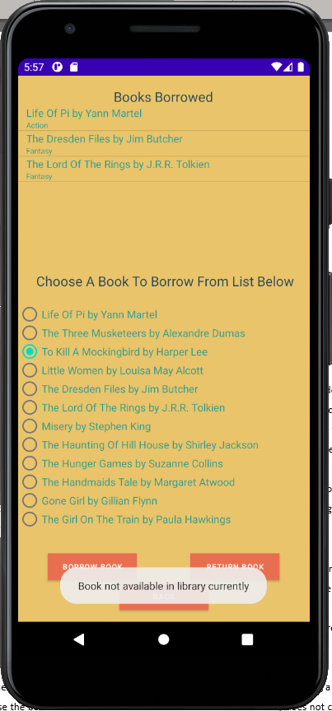

A toast appears when the user borrows or returns a book and in turn a toast appears if the book is currently borrowed and trying to borrow again, or is not currently borrowed and trying to be returned.

If the user tries to borrow more that 4 books, a toast appears to say it cannot be done and the list does not update with the selected title.

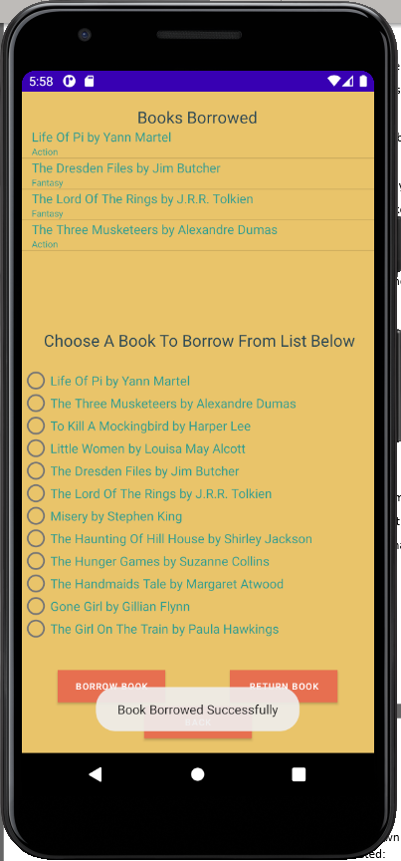

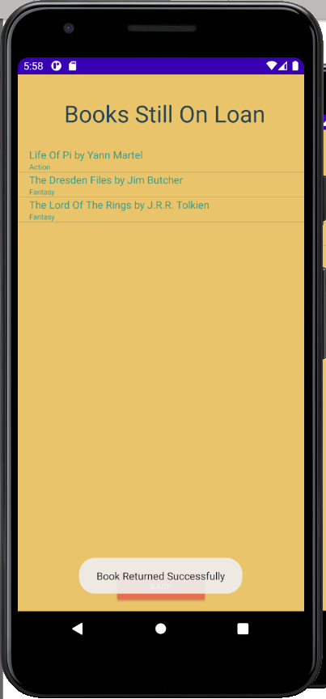

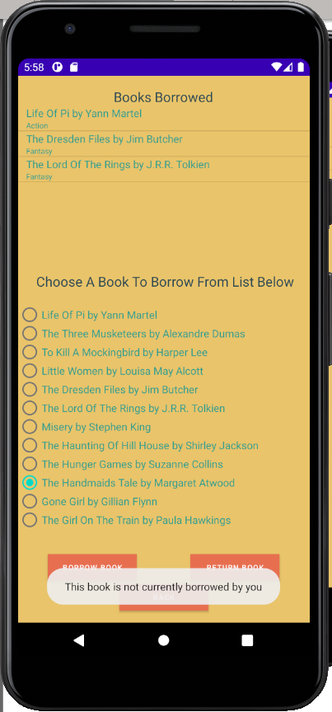

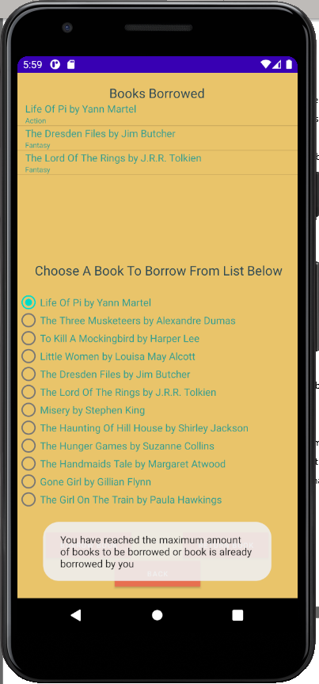

# Presentation and Style

I decided to use a warm palette and to also create my own logo based on the palette of colours I picked. Below are screenshots of each activity I created:

## Design of BooksActivity:

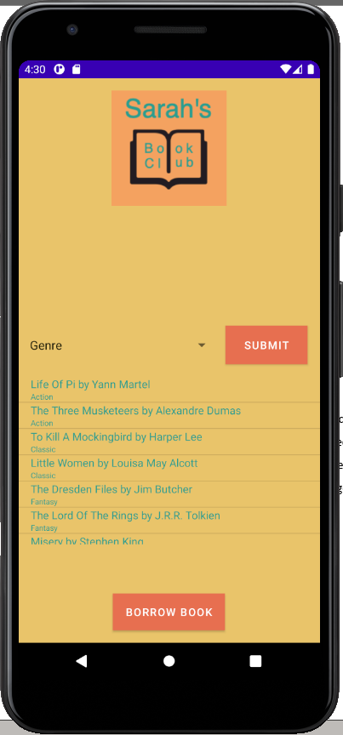

I created my own logo and placed it in both Books and Genre Activities. I placed a spinner and button that are used to go from Books to Genre Activity and only show the specific genre books in that activity. I then placed a ListView that uses a CustomListAdapter to display the book title, author and genre. Finally, I put a Borrow Book button at the end to allow the user to go to and borrow books from LoanActivity.

## Design of GenreActivity:

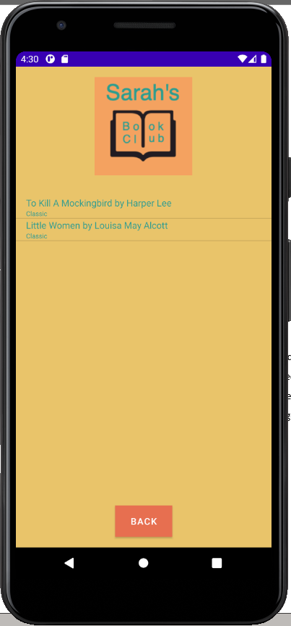

Placed the logo at the top. Put in the ListView with CustomListAdapter to display each book of the certain genre. Created a back button to easily go back to previous page.

## Design of LoanActivity:

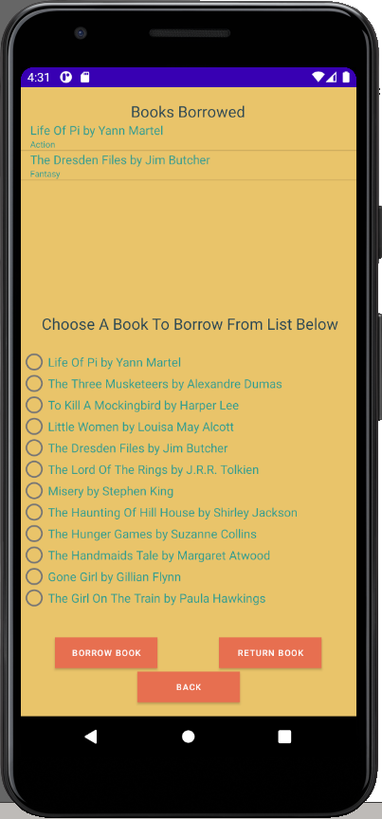

At the top of the screen I have a TextView which underneath has a ListView that lists the books that are currently loaned by the user.

Below this I have a TextView and a RadioGroup with RadioButtons that list each book in the library and you can either borrow or return the book depending on which button you click.

The back button brings you back to BooksActivity.

## Design of ReturnActivity:

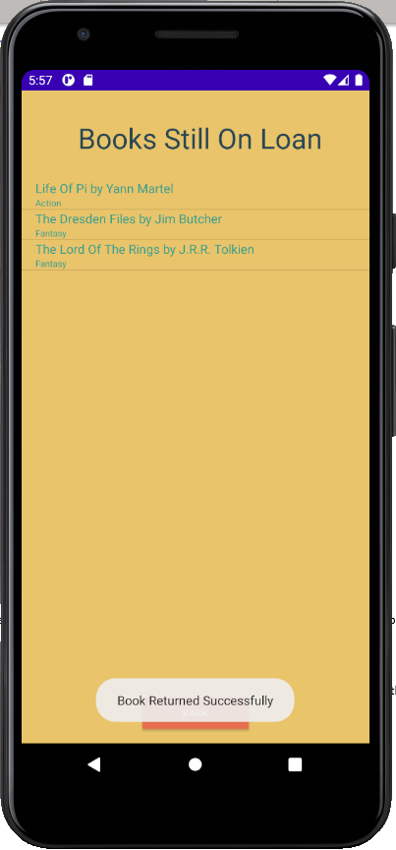

At the top I have a TextView and below is a ListView that shows all the books that the user has borrowed minus the book they have returned.

# Original Design

I originally thought I would create 5 activities which are shown below:

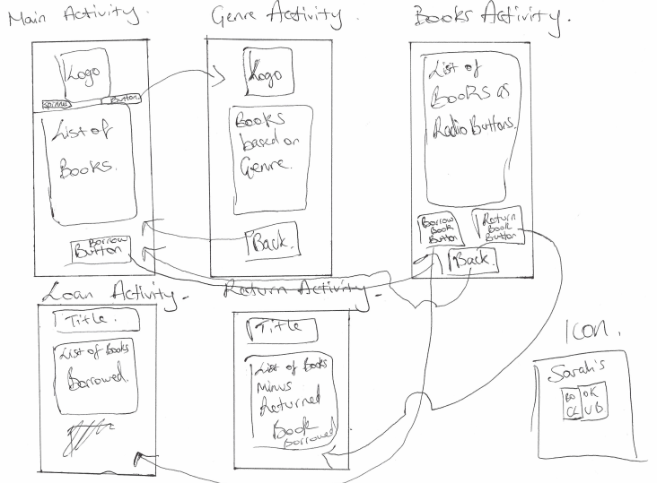

I could not figure out a way to have BooksActivity to be LoanActivity. I then found Bundle which allowed me to pass many parameters from on activity to another. Through this I created a button that went to the same activity again, but it updated both the ListView and the RadioGroup and meant I could get rid of the original LoanActivity as this was very similar to ReturnActivity. I also was then able to create a back button in ReturnActivity which I did not think I would be able to achieve. I also drew a quick sketch of what I wanted my logo to be.